“Tic-Tac-Toe AI Using Minimax Algorithm and Alpha-Beta Pruning for Optimal Decision-Making”

Nandini Das
2031326642
Department of Computer Science and Engineering,
North South University
Dhaka, Bangladesh
Syed Riaz Us Salatin Yeasin
2031061642
Department of Computer Science and Engineering,
North South University
Dhaka, Bangladesh

Nafiz Haider Chowdhury
1721587642
Department of Computer Science and Engineering,
North South University
Dhaka, Bangladesh
Tousif Iqbal
2012814642
Department of Computer Science and Engineering,
North South University
Dhaka, Bangladesh

Abstract—This report provides an update on the development of a Tic-Tac-Toe AI using the Minimax Algorithm and Alpha-Beta Pruning. The AI ensures optimal decision-making, never losing a game if played correctly. The project is implemented in Python and focuses on optimizing search space exploration for quick decision-making. The key challenges involve computational complexity and handling game scenarios efficiently.

Keywords— Tic-Tac-Toe AI, Minimax Algorithm, Alpha-Beta Pruning, Search Space Optimization, Computational Complexity, Game Tree Search

Introduction
The goal of this project is to create an AI capable of playing Tic-Tac-Toe optimally. This is achieved using Minimax, a recursive decision-making algorithm that evaluates all possible moves and their outcomes, and Alpha-Beta Pruning, an optimization technique that reduces unnecessary computations. The AI ensures a win or a draw when played optimally.

Methodology

Board Representation and Game Rules
The Tic-Tac-Toe board is represented as a 3x3 matrix, where each cell contains either 'X' for the AI's move, 'O' for the human player's move, or '-' for an empty space. The game follows standard rules: a player wins by aligning three of their marks in a row, column, or diagonal. If the board is completely filled with no winner, the game results in a draw. The AI and player take turns making moves until one of these conditions is met, ensuring a structured and fair gameplay flow.

Minimax Algorithm
The Minimax Algorithm ensures optimal gameplay by evaluating all possible future board states and assigning scores based on their outcomes. The AI aims to maximize its winning chances while assuming the opponent plays optimally. It assigns +1 for an AI win, -1 for an AI loss, and 0 for a draw. The algorithm works by recursively simulating all possible moves, assigning scores to terminal game states (win, loss, or draw), and then backtracking these scores through the decision tree. The AI selects the move that maximizes its minimum gain, ensuring it plays optimally.

The Minimax equation is formulated as:
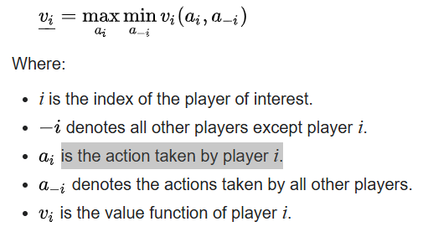

Alpha-Beta Pruning
Alpha-Beta Pruning optimizes the Minimax algorithm by reducing unnecessary evaluations, improving efficiency without affecting decision accuracy. The pruning process stops exploring branches of the game tree when it is already clear that a better move is available. This prevents the AI from analyzing game paths that won’t impact the final outcome, significantly reducing computational overhead.
The algorithm uses Alpha (AI’s best guaranteed score) and Beta (opponent's best guaranteed score) to prune unnecessary branches when Alpha ≥Beta, reducing board state evaluations by up to 50% for faster decision-making. The pruning conditions are α = max(α, v) if maximizing and β = min(β, v) if minimizing. If α ≥ β, the branch is cut off, improving Minimax efficiency for real-time AI decisions..

Update and results
- The Minimax algorithm has been successfully implemented, enabling the AI to play optimally. The AI has been tested and can now make strategic moves, ensuring a win or draw when played correctly.
- The AI effectively analyzes board states and selects the best moves using Minimax. Performance tests confirm that the AI consistently plays optimally, successfully blocking opponent moves and securing wins or draws.

.

Conclusion and future work
The implementation of the Tic-Tac-Toe AI using the Minimax Algorithm ensures optimal gameplay, with the AI consistently making the best possible moves. Alpha-Beta Pruning enhances efficiency, reducing computation time while maintaining decision accuracy. The AI has been successfully tested and can now play against human players, making strategic decisions in real time. The next step is to implement and optimize Alpha-Beta Pruning to further improve performance by pruning unnecessary branches, allowing faster decision-making. Future improvements may include expanding to larger board sizes and integrating a GUI for better user interaction.

References

- Minimax (2024) Wikipedia. Available at: https://en.wikipedia.org/wiki/Minimax (Accessed: 25 February 2025).
- madi, A. (2023) Tic-tac-toe agent using alpha beta pruning, Medium. Available at: https://medium.com/@amadi8/tic-tac-toe-agent-using-alpha-beta-pruning-18e8691b61d4 (Accessed: 25 February 2025).

